**BTEC Extended Certificate**

in Creative Digital Media Production

**UNIT 11: Animation for Digital Media**

**TASK 2: Planning Producing and Evaluation an Animation**

**Learner’s Name: Aaron Coleman**

**Learner declaration**

I certify that the evidence submitted for this assignment is my own. I have clearly referenced any sources used in the work. I understand that false declaration is a form of malpractice.

**Learner signature:acoleman313@howcollege.ac.uk**

**Date: 06/05/2016**

# 

# Pre-Production Planning

## Mind Map

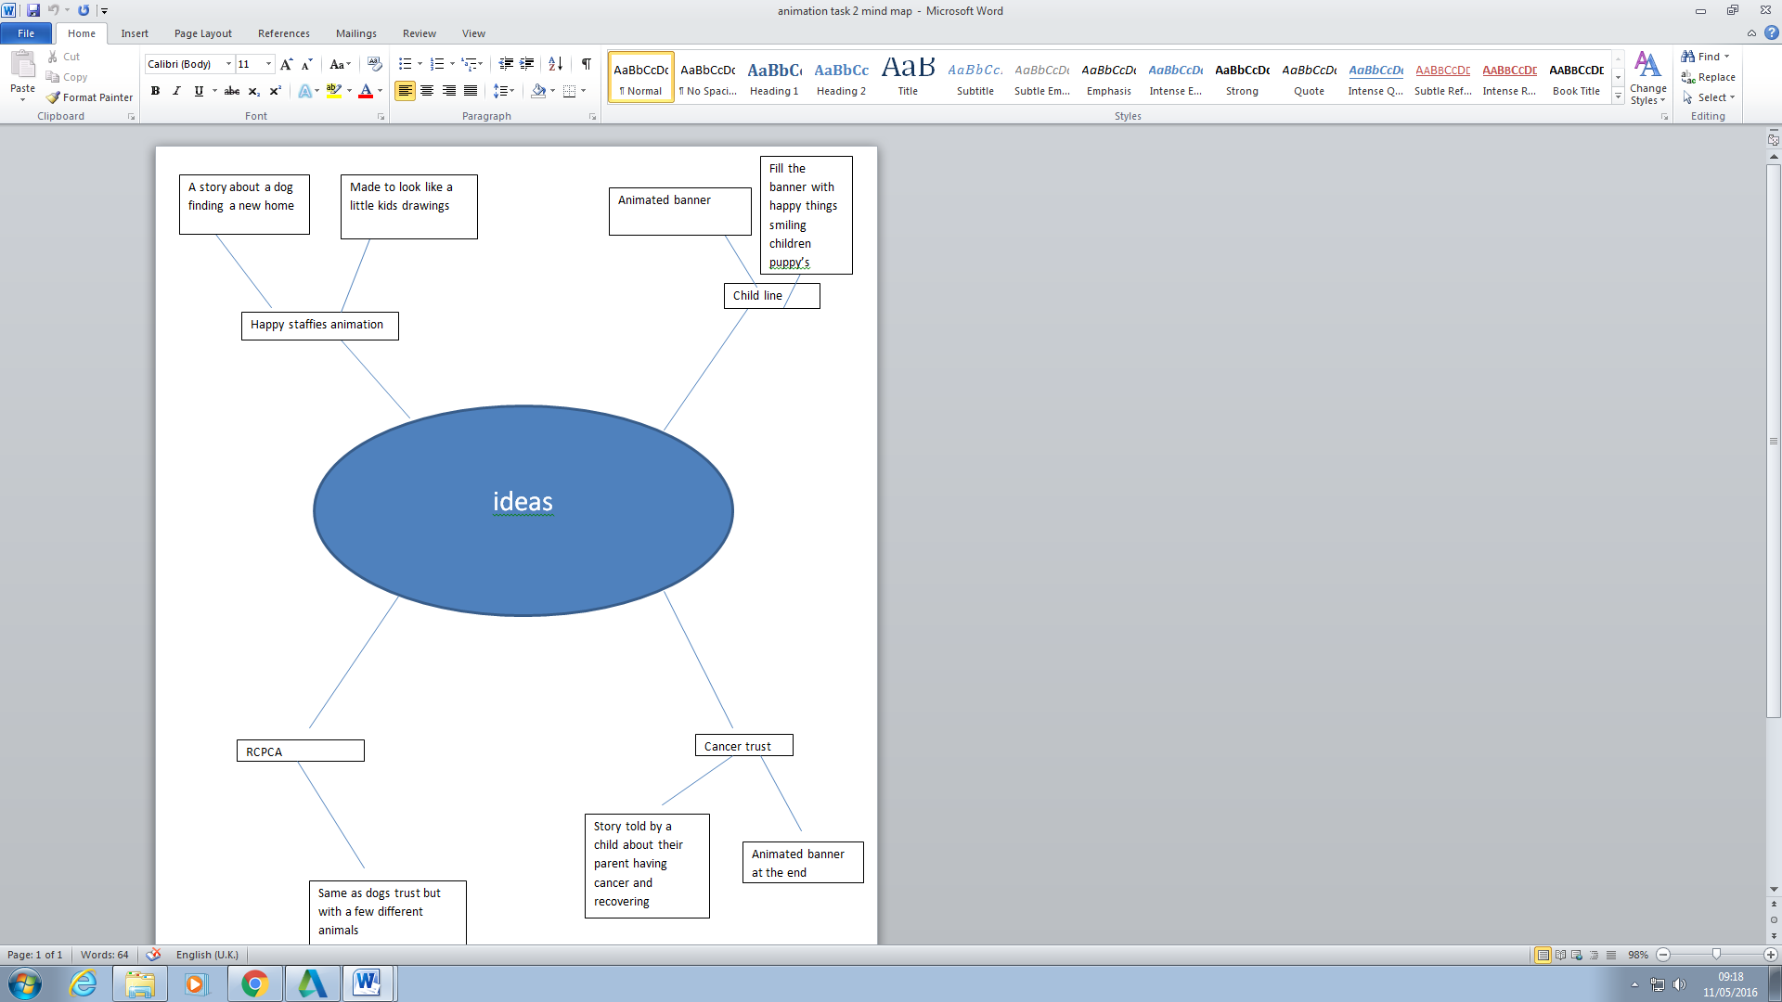

## Annotated Diagrams

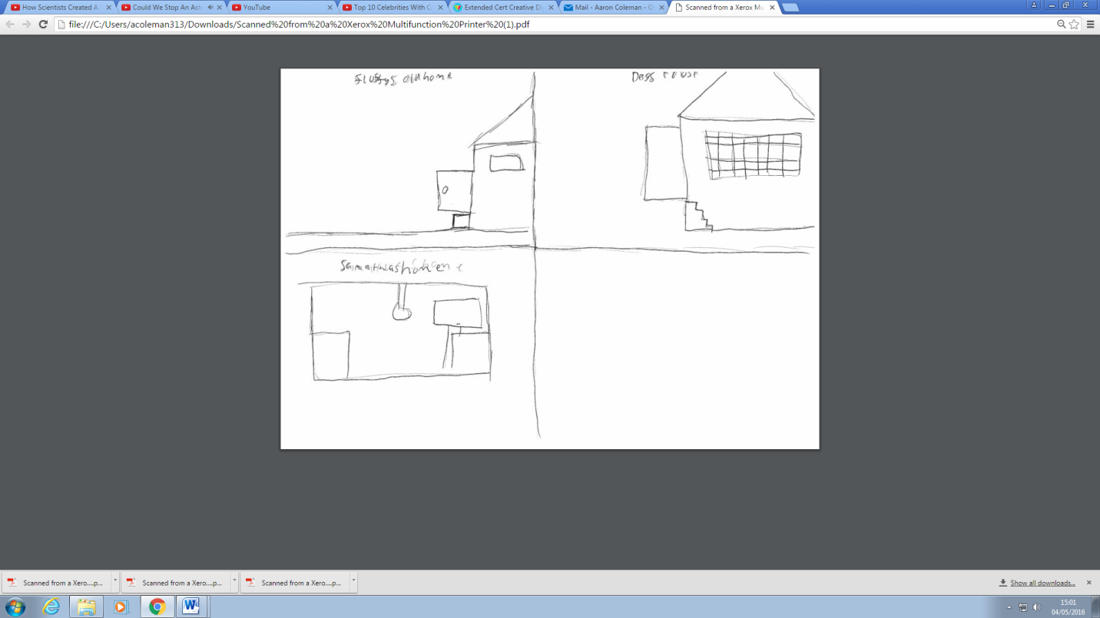

Samantha’s home

Fluffy old home

Happy staffies

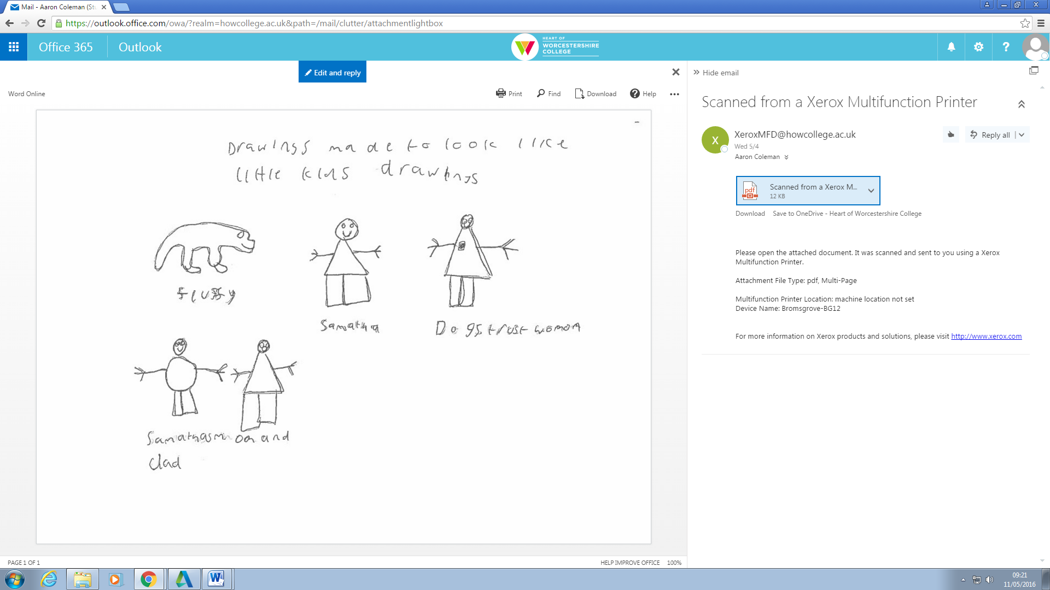

Happy staffie woman

Samantha

These drawings were made to look like child’s drawings

Fluffy

Samantha’s mom and dad

## Description of the scene including reasons for choices made.

Description of scene

At the beginning after the intro fluffy will be chased out of the house and a speech bubble will appear with a narrative for the story then a lady will find fluffy with a speech bubble of what he was liked when he was found then it transitions to when fluffy is being adopted with a speech bubble about how he was when he was adopted then transitions to Samantha’s house with a speech bubble about how he is now and then the outro queues and that’s the end.

## i chose this because

I chose this idea because I love dogs and it’s a simple but effective idea and can be done within the time frame plus people take more information when there’s something they can see that is not just writing. I also chose this because of the effectiveness of this type of video it shows a story which can be absorbed easier as well as having it look like a little kids drawings so young children can understand the pictures so the animation can be absorbed to everyone so because this is a animation for happy staffies so because most of the people who adept dogs from a sanctuary would

## Storyboards

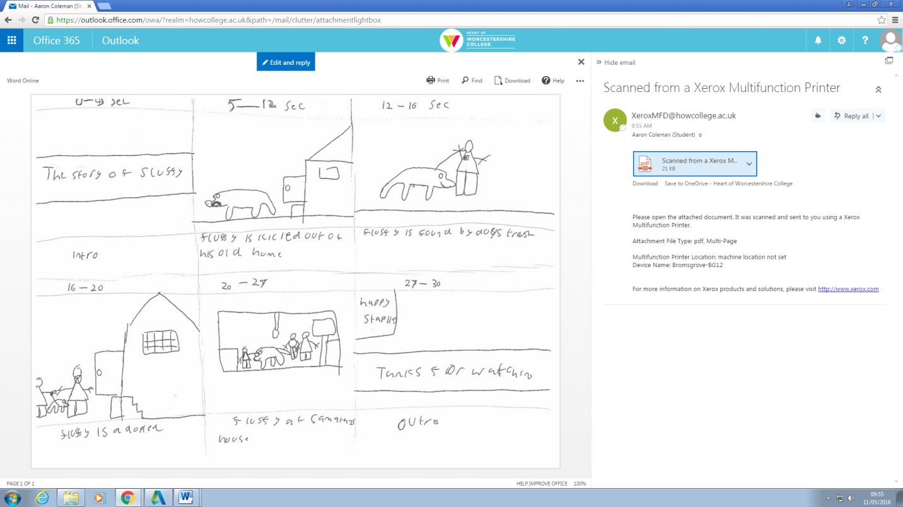

Thanks for watching

Outro

Fluffy at Samantha’s house

Fluffy is adopted

9-12

7-9

5-7

3-5

1-3

0-1

Fluffy is found by happy staffhies

Fluffy is kicked out of his old house

intro

The story of fluffy

## Production Schedule

# Evaluation

## audience feedback

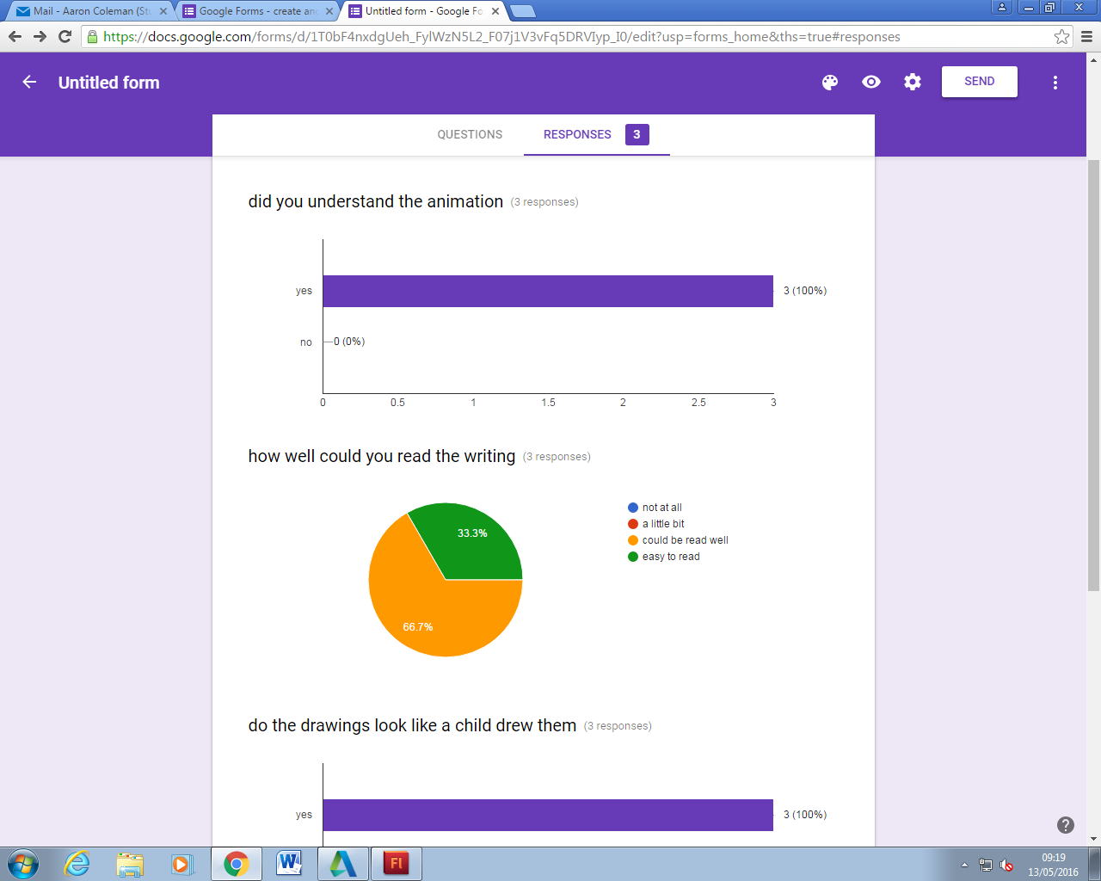

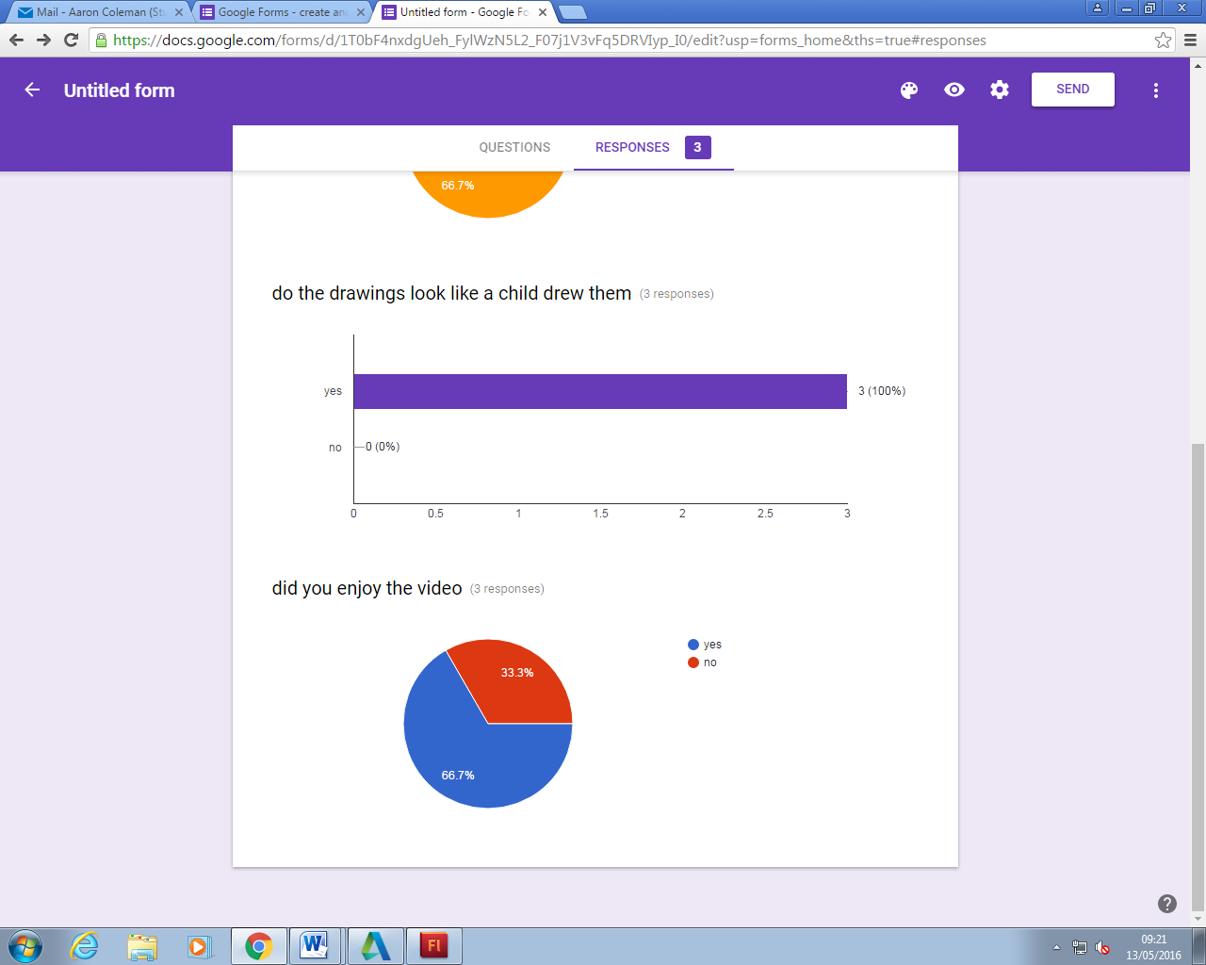

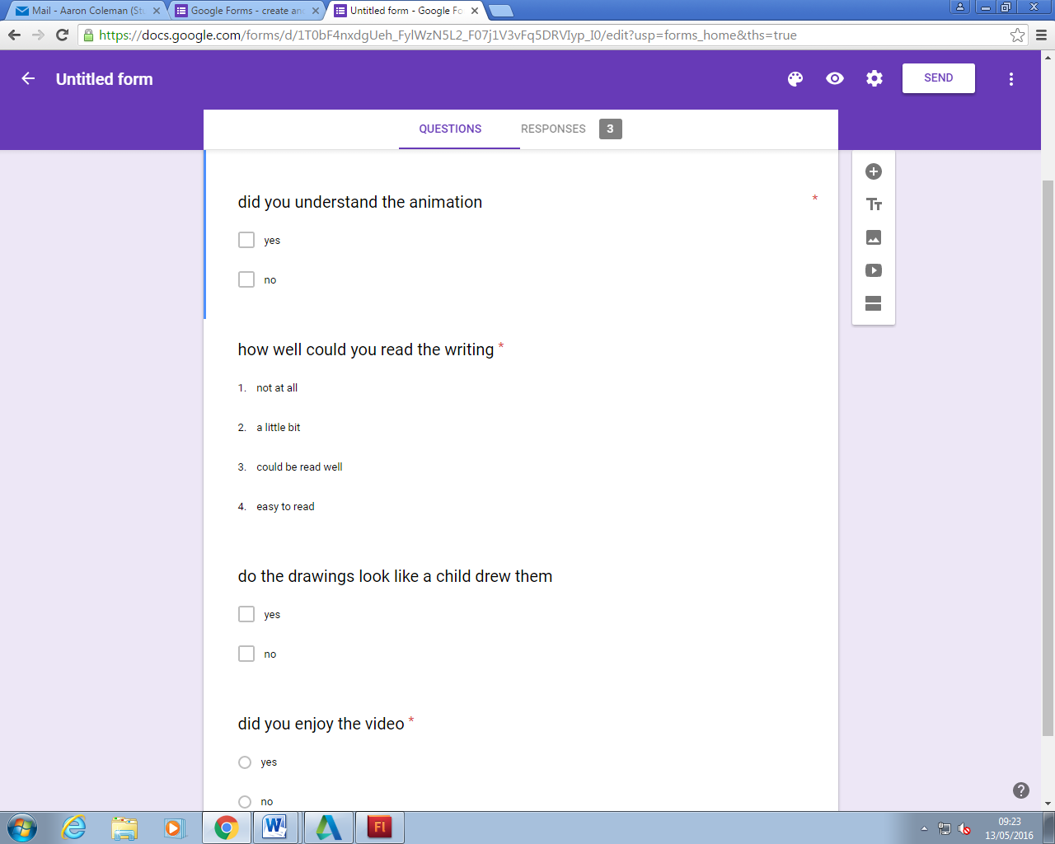

## Self-reflective Evaluation

This animation purpose is to show the story of a dog getting adopted from a canal of happy staffies and is intended for young to old audiences. The style of the animation was made to look as if a little kid drew it to give the young ones some familiarity and keep them engaged the text is readable and stays on the screen long enough to be read. The techniques I used was the pen toll movement tweaks and shapes and texts all of which came out as they were supposed to but I do need to improve with shapes as I’m not very good at getting the right size.

# References

**Happy staffies site** [**http://www.happystaffierescue.org.uk/**](http://www.happystaffierescue.org.uk/)